

Project Report

Information Portal for Soccer Fan



Contents

1. Definition of the Problem 2

2. Requirement Analysis 3

3. Design Phase 3

4. Architecture of Website 4

5. Evaluation/Testing 4

6. Project Tracking and Monitoring Activities 5

7. Documentation Section 6

8. Source Code 21

9. User Guide 21

Definition of the Problem

We have designed and build a website named **'Soccer Verse'** which is intended to help Soccer fans to get information about teams, players, tournaments, lineups and matches easily and quickly on one website without any problem and to learn about Soccer and it's history

Requirement Analysis

**List of Outputs expected from the system:**

1. Soccer players Information.
2. Teams information.
3. Game Schedules and Results.
4. Top Scores and Rankings.
5. Site map.
6. Means to contact us.
7. a section to leave reviews.

**Overview of processes:**

**Expected delivery dates:**

**List of deliverables:**

**Hardware Requirements:**

1. Intel Core i5 Processor or higher
2. 8 GB RAM or higher
3. Color SVGA
4. 80 GB Hard Disk space
5. 500 GB Hard Disk space
6. Mouse
7. Keyboard

**Software Requirements:**

1. Frontend: HTML5, CSS3, Bootstrap (optional), JavaScript, Figma Toolkit, jQuery, AngularJS/Angular 9/ReactJS, and XML
2. Data Store: JSON/TXT
3. Bootstrap 3.3 libraries from getbootstrap.com, jQuery plugins, owl carousel , Notepad++, or other HTML editor

**Scope of the work:**

1. **Website should display soccer info**

Design Phase

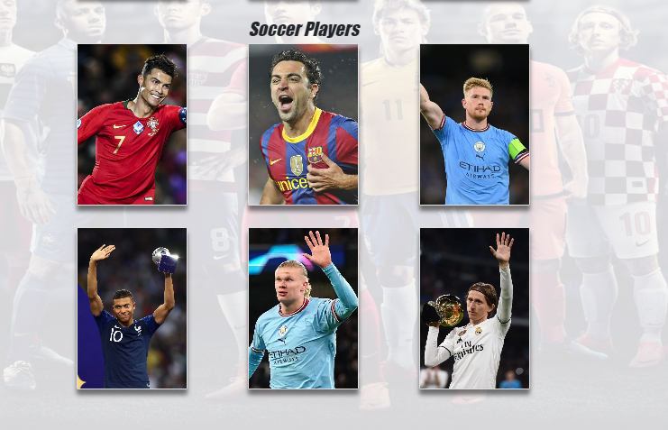

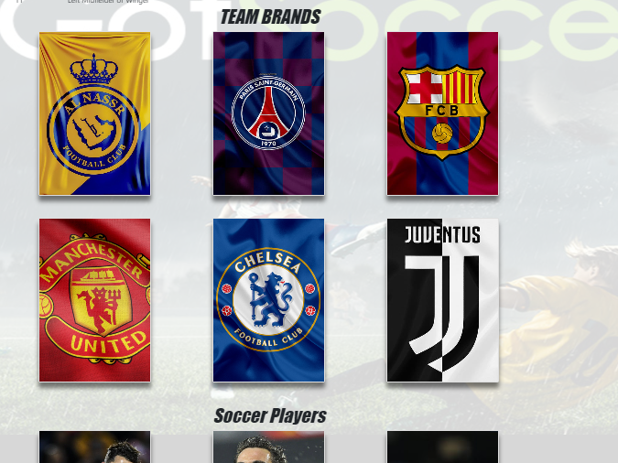

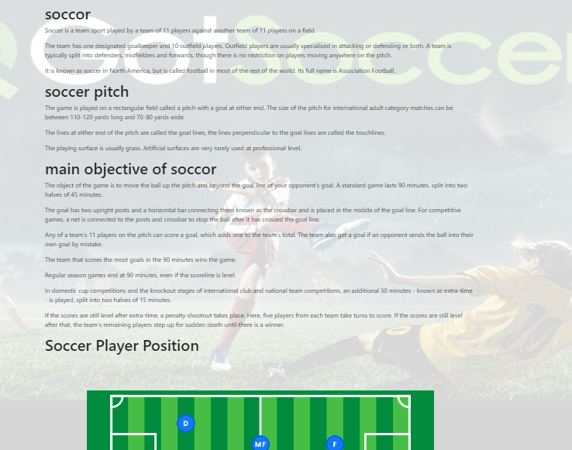

Architecture of Website

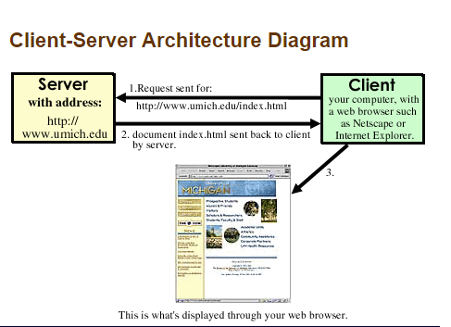

**Figure 1.1: Website Architecture**

**Figure 1.2: Site Map**

Evaluation/Testing

Over all website is working accurate but in forms some validations are not working but over all website is working fine. Links are broken requirements aren’t complete

Project Tracking and Monitoring Activities

|  |  |  |  |
| --- | --- | --- | --- |
| **Project Name** | **Team Name** | **Team Members** | **Roles** |
| SoccerVers | Web Majes | Ali | Website, Logo designing |
| SoccerVers | Web Majes | Asim | Images Data Collection |
| SoccerVers | Web Majes | Zeshan | Documentation |

Documentation Section

|  |  |  |
| --- | --- | --- |
| **Design Plan:** | **Document Name:**  **Problems Of Defination** | **SWD/Form No. 1** |
| **Effective Date:12/8/23** | **Version: 4** | **Page No. 16** |

PROBLEMS OF DEFINATION

We have designed and build a website named **'Soccer Verse'** which is intended to help Soccer fans to get information about teams, players, tournaments, lineups and matches easily and quickly on one website without any problem and to learn about Soccer and it's history

|  |  |
| --- | --- |
| **Date** | **Prepared By (Student)** |
| **12/8/23** | Ali Abdullah (Student1424981)  Zeeshan Khan(Student1425005),  Asim Munnir(student1425002), |

|  |  |  |
| --- | --- | --- |
| **Design Plan:** | **Document Name: Customer Acceptance Criteria (CRS)** | **SWD/Form No. 2A** |
| **Effective Date:25/3/19** | **Version: 1** | **Page No. 17** |

Client/Project Undertaken: ____________________________________________

1. **List of outputs expected from the system**

* We have given helpline numbers. i.e. police or rangers helpline numbers
* Self-defense tips in video.
* Eyewitness audio statements.
* Safety measures by given images.
* Also we provide some hero women’s stories that defense against crime.
* Campaign ideas
* We show some unsafe areas.
* Some reports are given.
* Contact us by contact form.
* We give helpline numbers. i.e. police or rangers helpline numbers

1. **Overview of Processes involved in the system**
2. **Hardware and Software required for implementing the project**

**Hardware Requirements:**

1. Intel Core i5 Processor or higher
2. 8 GB RAM or higher
3. Color SVGA
4. 500 GB Hard Disk space
5. Mouse
6. Keyboard

**Software Requirements:**

1. . Frontend: HTML5, CSS3, Bootstrap (optional), JavaScript, Figma Toolkit, jQuery, AngularJS/Angular 9/ReactJS, and XML
2. Data Store: JSON/TXT

|  |  |
| --- | --- |
| **Date** | **Prepared By (Student)** |
| **12/8/23** | Ali Abdullah (Student1424981)  Zeeshan Khan(Student1425005),  Asim Munnir(student1425002), |

|  |  |
| --- | --- |
| Student1425005 | Zeeshan Khan |
| Student1424981 | Ali Abdullah |
| student1425002 | Asim Munnir |

|  |  |  |
| --- | --- | --- |
| **Design Plan:** | **Document Name:**  **CRS** | **SWD/Form No. 2B** |
| **Effective Date:12/8/23** | **Version: 4** | **Page No. 19** |

|  |  |
| --- | --- |
| **S.No.** | **Customer’s Acceptance Criteria** |
| 1. | When requirements are fulfilled |
| 2. | When the agreement is completed |
| 3. | After deployment, when testing process is completed |
| 4. | When validation are working properly |
| 5. | When all the linking are working properly |
| 6. | When the UX/UI is perfectly done |
| 7. | When it is delivered on time |
| 8. | When domain hosting is being purchased |
| 9. | When website is live on the internet properly |
| 10. | When the cost of the given project is under budget |

|  |  |
| --- | --- |
| **Date** | **Prepared By (Student)** |
| **12/8/23** | Ali Abdullah (Student1424981)  Zeeshan Khan(Student1425005),  Asim Munnir(student1425002), |

|  |  |  |
| --- | --- | --- |
| **Design Plan:** | **Document Name: Project Plan** | **SWD/Form No. 3** |
| **Effective Date:12/8/19** | **Version: 4** | **Page No. 20** |

**Project Plan**

1. **Project Details**

* **Name of the Client:**_Aptech Landhi
* **Date of the Project Plan:**

___12th-Mar-2023

* **Project Vision/Objectives:**

(Define the project vision/objectives as stated by the client)

Project was based on Women self-defense website where multiple tactics and awareness of some areas which was unsafe.

* **Scope:**

(Mention the scope of the project giving the location that will be covered, processed, range of services, and so on)

Given project covers self-defense tips for women to protect oneself from unaware violence or harassment.

* + **Our understanding of the client organization**

(Give the range of services, functions, overview of processes, and so on)

We provided multiple videos on self-defense and Eye witnesses accounts who were present on the incident place,

* + **Project Organization with Responsibilities and Authorities**

(Give the name of Project team members their roles and responsibilities)

|  |  |  |  |
| --- | --- | --- | --- |
| Project Name | Team Name | Team Members | Roles |
| Soccer Vers | WebMajes | ali | Website, Logo designing |
| Soccer Vers | WebMajes | Asim | Images Data Collection |
| Soccer Vers | WebMajes | Zeshan | Documentation |

1. **Project Initiation/Requirement Documents**

(Information required from the client as inputs regarding his/her system; could be the information about the services, processes, and so on)

We have followed all the requirements given from the client and all processes of SRS is completed.

1. **Deliverables**

(The documents to be handed over to the client – such as CRS, Design Document, Installation Manual, User Manual, Maintenance Manual, and Code of documents)

* Documentations
* User manual
* Source code
* Assets

1. **Project Dependencies**

(Any event or task outside the scope of the project which will affect the success of the project)

A theme was used and we fully customized the template using JQuery, bootstrap, embedded videos and owl carousel.

1. **Major Project Milestones**

(Generating CRS and Building a Prototype)

1. **Quality Plan** 
   * **Review Activities** (Review meeting participants, frequency and so on)
   * **Testing Activities** (Final Test)

We have completed our website according to SRS and tested it, working 100% fine.

* + **Backup and Recovery Strategies** (In case of disk crash, network failures, and so on)

We have made a backup on drive, In case of disk crash we can provide a copy.

|  |  |
| --- | --- |
| **Date** | **Prepared By (Student)** |
| **12/8/23** | Ali Abdullah (Student1424981)  Zeeshan Khan(Student1425005),  Asim Munnir(student1425002), |

|  |  |  |
| --- | --- | --- |
| **Design Plan:** | **Document Name: GUI Standard Document** | **SWD/Form No. 4** |
| **Effective Date:12/8/23** | **Version: 4** | **Page No. 23** |

**Document Design**

|  |  |
| --- | --- |
| **Property** | **Value** |
| Document Theme and Color Scheme | **White, Black, Blue** |
| Form-Background Color | **White** |
| Title-Font Size | **22** |
| Title-Font Color | **Black** |
| Title-Font Style | **Baskerville Old** |
| Title-Alignment | **Center** |
| Background color of Controls on the form | White |
| Foreground color of Controls on the form | Black |
| Control Caption-  Font Size |  |
| Control Caption-  Font Color |  |

|  |  |
| --- | --- |
| Control Caption-  Font Style |  |
| Control caption and controls-Alignment |  |
| Command button-Alignment |  |

|  |  |
| --- | --- |
| **Date** | **Prepared By (Student)** |
| **12/8/23** | Ali Abdullah (Student1424981)  Zeeshan Khan(Student1425005),  Asim Munnir(student1425002), |

|  |  |  |
| --- | --- | --- |
| **Design Plan:** | **Document Name: Interface Design Document** | **SWD/Form No. 5** |
| **Effective Date:12/8/23** | **Version: 4** | **Page No. 25** |

**1. List of forms to be created**

|  |  |  |
| --- | --- | --- |
| **Page/Form Name** | **Description** | **Controls on the Page/Form** |
| Home | Home page with basic info |  |
| Self-defense tips | Videos containing self-defense tips. |  |
| Eye witness | Audio stories of eyewitnesses who have seen crimes against women happening. |  |
| Safety measures | Safety measures that can be undertaken by women to keep themselves safe. |  |
| Women heroes | Image gallery with stories of women heroes who fought successfully against a crime. |  |
| Campaign ideas | Ideas in bulleted form for campaigns based on which you can start your own campaign |  |
| Unsafe areas | List of unsafe places inside the city in a tabular grid. |  |
| Reports | Reports of crimes against women based on sorted order of date or location. |  |
| Helplines | important helpline phone numbers. |  |
| Contact Us | Email id, address, and contact number of the team behind Eve Plus. |  |

|  |  |
| --- | --- |
| **Date** | **Prepared By (Student)** |
| **12/8/23** | Ali Abdullah (Student1424981)  Zeeshan Khan(Student1425005),  Asim Munnir(student1425002), |

|  |  |  |
| --- | --- | --- |
| **Design Plan:** | **Document Name: Interface Design Document** | **SWD/Form No. 6** |
| **Effective Date12/8/23** | **Version: 4** | **Page No. 26** |

1. **Process/Module Name**

|  |  |
| --- | --- |
| Home | Home page with basic info |
| Self-defense tips | Videos containing self-defense tips. |
| Eye witness | Audio stories of eyewitnesses who have seen crimes against women happening. |
| Safety measures | Safety measures that can be undertaken by women to keep themselves safe. |
| Women heroes | Image gallery with stories of women heroes who fought successfully against a crime. |
| Campaign ideas | Ideas in bulleted form for campaigns based on which you can start your own campaign |
| Unsafe areas | List of unsafe places inside the city in a tabular grid. |
| Reports | Reports of crimes against women based on sorted order of date or location. |

1. **Process/Module Description and Details**

|  |  |
| --- | --- |
| Home | Home page with basic info |
| Self-defense tips | Videos containing self-defense tips. |
| Eye witness | Audio stories of eyewitnesses who have seen crimes against women happening. |
| Safety measures | Safety measures that can be undertaken by women to keep themselves safe. |
| Women heroes | Image gallery with stories of women heroes who fought successfully against a crime. |
| Campaign ideas | Ideas in bulleted form for campaigns based on which you can start your own campaign |
| Unsafe areas | List of unsafe places inside the city in a tabular grid. |
| Reports | Reports of crimes against women based on sorted order of date or location. |

|  |  |
| --- | --- |
| **Date** | **Prepared By (Student)** |
| **12/8/23** | Ali Abdullah (Student1424981)  Zeeshan Khan(Student1425005),  Asim Munnir(student1425002),  **)** |

|  |  |  |
| --- | --- | --- |
| **Design Plan:** | **Document Name: Task Sheet** | **SWD/Form No. 7** |
| **Effective Date: 12/8/23** | **Version: 4** | **Page No. 27** |

|  |  |  |  |  |  |
| --- | --- | --- | --- | --- | --- |
| **Date:** | **Project Plan/ Milestone** | **Work**  **Specification** | **Status of the Activity** | **Remarks** | **Responsibility** |
| 25/3/2019 | Analysis | Requirements  Get from SRS/  Paper working/  Project plain | Yes | good | MUHAMMAD HAMMAD SHAIKH(Student1133772)  RAMEEZ(Student1134415)  ARZOO(Student1158172) |
| 25/3/2019 | UI Screen Design | Complete all website screen | Yes | Excellent | MUHAMMAD HAMMAD SHAIKH(Student1133772)  RAMEEZ(Student1134415) |
| 25/3/2019 | Data Collection like (images,  Video, audio) | Data Collect  As per requirement | Yes | Good | ARZOO(Student1158172) |
| 26/3/2019 | Backend code (Source Code)  Consolidate in one project | Complete all backend code | Yes | Excellent | MUHAMMAD HAMMAD SHAIKH(Student1133772)  RAMEEZ(Student1134415) |
| 26/3/2019 | Testing | All website testing | Yes | Good | MUHAMMAD HAMMAD SHAIKH(Student1133772)  RAMEEZ(Student1134415) |
| 27/3/2019 | Documentation | Complete documentation as per SRS/Project Plain | Yes | Good | USAMA(student1133759) |

|  |  |
| --- | --- |
| **Date** | **Prepared By (Student)** |
| **12/8/23** | Ali Abdullah (Student1424981)  Zeeshan Khan(Student1425005),  Asim Munnir(student1425002), |

Final Check List

|  |  |  |
| --- | --- | --- |
| **Design Plan:** | **Document Name: Final Check List** | **SWD/Form No. 8** |
| **Effective Date: 12/8/23** | **Version: 1** | **Page No. 28** |

|  |  |  |
| --- | --- | --- |
| **S.No** | **Aspect Tested** | **Suggestion/Remarks** |
| 1. | Have all the modules been properly integrated and are they completely functional? | yes |
| 2. | Does each unit meet its objective and purpose?  Are all the validations happening properly? | yes |
| 4. | Is the GUI design consistent all over? | yes |
| 5. | Are the codes working as per specification? | yes |
| 6. | Does the application’s functionality resolve the client problem, and satisfy his/her needs completely? | yes |
| 7. | Have the hardware and software been correctly chosen? | yes |
| 8. | Additional features and utilities that give value addition to the entire project. | yes |

|  |  |
| --- | --- |
| **Date** | **Prepared By (Student)** |
| **12/8/23** | Ali Abdullah (Student1424981)  Zeeshan Khan(Student1425005),  Asim Munnir(student1425002), |

Source Code

**Side Bar Buttons**

**Navigation Bar**

**Button CSS**

**JQuery Code**

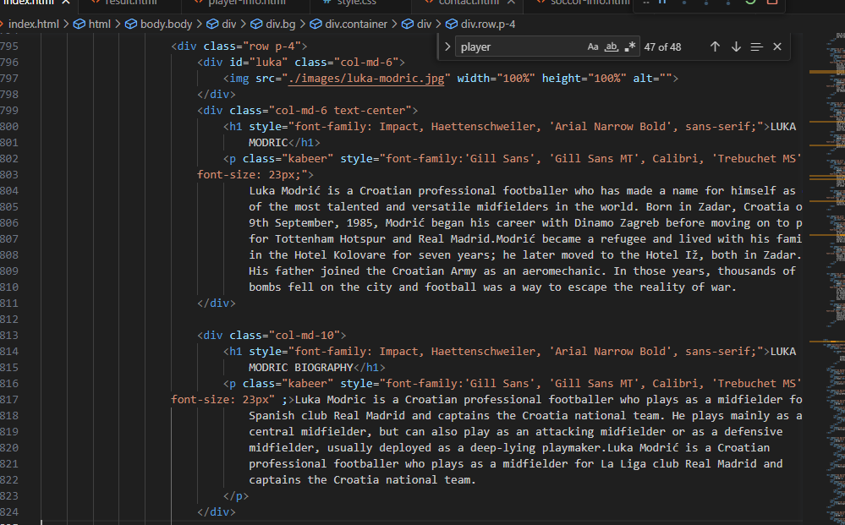

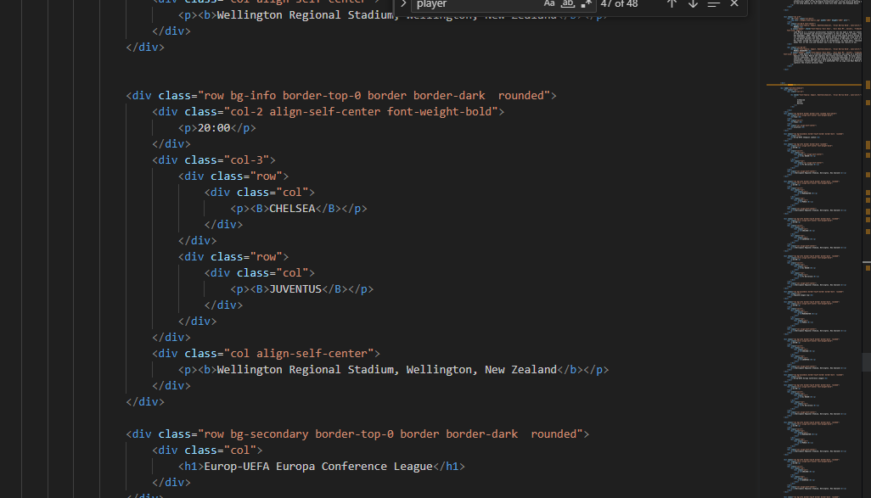

User Guide

1. **System Requirements:**

|  |  |  |  |
| --- | --- | --- | --- |
| **S.No** | **Browsers** | **Operating Portal** | **Ram/Memory** |
| **1** | Edge, Chrome, Mozilla Firefox, Safari | Windows | Minimum 512 MB or better |

1. **Host the Site:**

Please find below the FTP link , User ID and password through can upload your respective TechWiz Project.

**Software** : <https://winscp.net/eng/index.php>

**Installation:** Download winscp software and install into PC

**SR Username :** 1Pakistan

**Password :** Aptech@12345!

**Port Number :** 2121

**Host Name:** 113.193.48.175

**THANK**

**YOU**